AppBot

Streaming Profiler to App-V

www.appbot.de

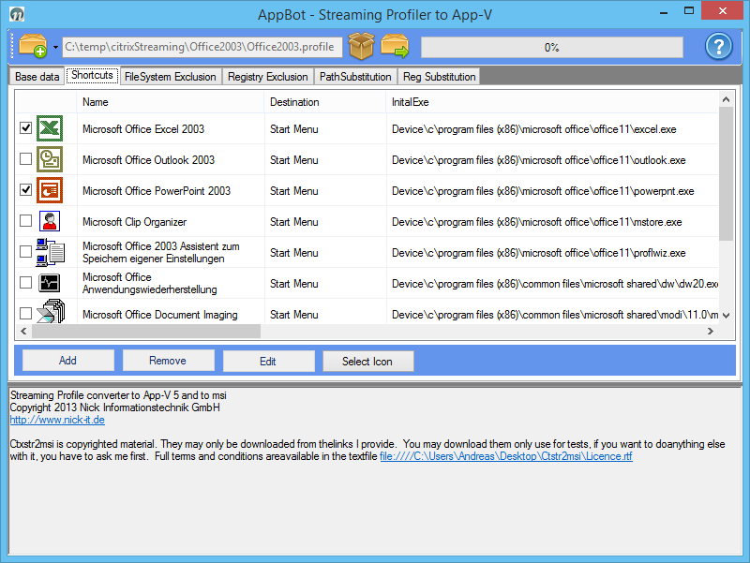

|  |  |  |
| --- | --- | --- |
| Version: | 1.0 | |
| Status: | Abgeschlossen 11/2013 | |
| Erstellt: | 29.11.2013 | Andreas Nick |

THIS DOCUMENT IS COPYRIGHTED BY THE NICK INFORMATIONSTECHNIK GMBH. THIS DOCUMENT MAY BE NOT COPIED OR REDISTRIBUTED WITHOUT THE WRITTEN CONSENT OF NICK INFORMATIONSTECHNIK. NICK INFORMATIONSTECHNIK RESERVES THE RIGHT ANY TIME TO CHANGE PRODUCT SPECIFICATIONS DESCRIBED IN THIS DOCUMENTATION AND TO CORRECT IT.

**3th Paty applications in AppBot**

**Windows Installer XML:** The Licence Areement (vor this version Microsoft Reciprocal License) is in the WIXBIn Folder in the File Licence.txt. Or <http://wixtoolset.org/about/license/> and in the installed Folders

**reglookup the licence textfile is in the installed Folders (commandline Tool)[1]**: <http://projects.sentinelchicken.org/reglookup/>

Content

1. AppBot Streaming Profiler to App-V 4

1.1 Features 5

1.2 AppBot is tested on and with: 5

1.3 Architecture-related restrictions 5

1.4 Planed features 5

2. Installation of AppBot 6

2.1 Install the Application 6

3. User Guide 10

3.1 Main Application Dialog 10

3.2 Description of the fields 12

3.3 Shortcut Management 14

3.4 FilesSystem Exclusion 15

3.5 Registry Exclusion 17

3.6 Path Substitution 20

3.7 Reg Substitution 22

4. Troubleshooting 23

4.1 Missing substitution 23

4.2 Log analysis 23

4.3 Creation of updates 23

5. Links 24

# AppBot Streaming Profiler to App-V

AppBot a tool that is created to transform Citrix Streaming Profiler Applications to Microsoft App-V 5. The Application create also a “real” Microsoft Installer Files for every application. So you can decide to install a msi for your “old” Streaming Profiler application (sccm, matrix 42 or so) or a App-V 5 package.

We transform also the installed platform Plattform. For example a Streaming Profiler application Windows Server 2003 to Windws 8 or Server 2012. Also if you “clicked” only Windows XP and Server 2003 in the Streaming Profiler. The complead filesestem, all registry keys and all shortcuts are rewritten. App-V can find every file and dll on the new location. We redirect every installation to “%programFiles%\NICK-IT\Applicationname” per default! You can change this settings maybe to “YOURCOMPANYNAME\Application”

The development of this Version is completed. We tested with streaming Profiler 6.0 (older versions maybe works but we don’t decompress the capfiles in these versions).

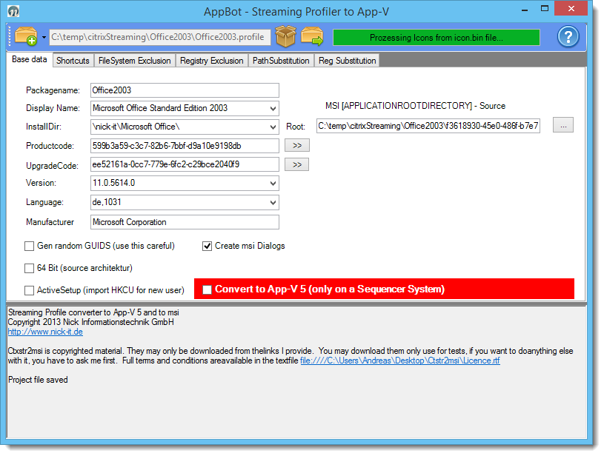

**ATTANTION**: It is recommended to use the generated App-V Package and not the MSI. A virtualization process produce many trash in the registry and the Filesystem. So unneeded settings are in the App-V Package (Sandbox) and not on your system. If you like to use the MSI, test it very careful in your Testenvironment.

## Features

* Automatic convert Citrix Streaming Profiler Packages to App-V 5
* Automatic detect .profile settings from the package (work in 9/10 packages)
* Get a „real“ msi for every Streaming Profiler (maybe for the config manager)
* Support User Profiles with ActiveSetup. You can hat this to yout Streaming Package
* Convert Windows XP and Server 2003 Packages to Server 2008 an 2012
* Convert your 16 Bit Installer Packages with 32 Bit Applications (KeyTerm!)
* Redirect Packages to a new location (default %programfiles%\nick-it\<Appname>
* Select your shortcuts!
* Solve also Profile virtualization Problems
* Get ALL Icons of a application from the Citrix Icon.bin file. This Icons can use for Publishing with XenApp

## AppBot is tested on and with:

* Streaming Profiler 6.x
* Test Streaming packages from Windows xp 32 Bit (german), Windows 7 32 Bit and Windwos 7 64 Bit
* Test transfomration System, running the AppBot: Windows 8.1 64 Bit and Windows 7 32 Bit
* Testpackages: Windows XP 32, Office 2003 (Word, Excel an PowerPoint running), Notepad++, 7Zip, Firefox, MagicIso, NVU, OpenVpn, Sqvaw, VLC Player, WinScp, XmlNotepad

## Architecture-related restrictions

This missing features are partly Application Streaming related!

* no App-V 5.0 SP 2 Context Menu Support in this Version (Winzip, Winraw for example)
* Services
* Device Drivers
* Update of Packages

## Planed features

* Bulk operations
* Command line Interface
* A „real usable“ converter for App-V 4.6 packages
* Automatic Export to ThinApp
* Package Wizzard
* Support for the old Streaming Profiler format
* Support for profiler scripts in App-V 5
* Update Support (Updates creates with the Citrix Streaming Profiler)

# Installation of AppBot

**Installation Requirements**

* Windows 7 (32 /64 bit ) or Windows 8/8.1 (32/64 bit)
* .NET Framework 4.0 http://www.microsoft.com/en-us/download/details.aspx?id=17718
* PowerShell 3.0 <http://www.microsoft.com/en-us/download/details.aspx?id=34595>
* App-V 5.0 Sequencer (for an automatic transformation to App-V 5. Not needed if you only wand a MSI)

These requirements are not checked by the installer. If the Application not run in cour environment, please install the requirements

## Install the Application

Start the Installer **AppBotCtxStr2AppV1.0.msi**

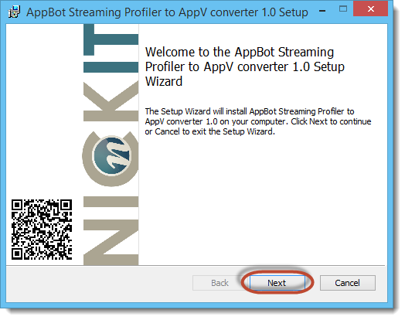

Click „Next“

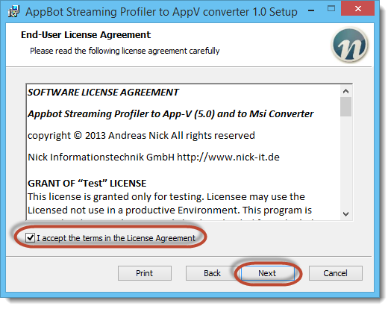

Read the Licence Areement and accept ist. Click Next

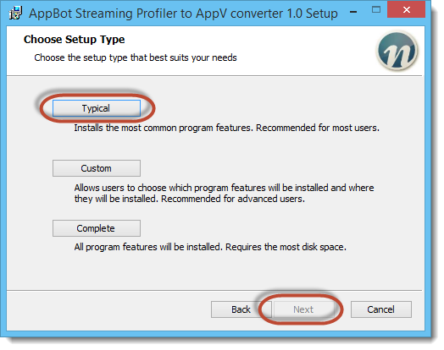

Click „Typlical“ and „Next“

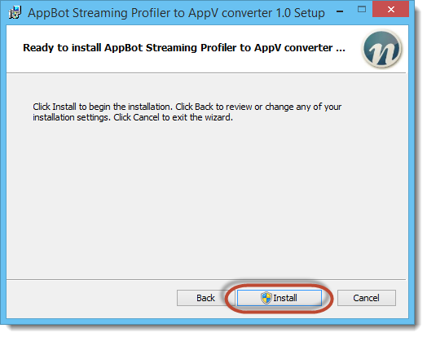

Click „Install“

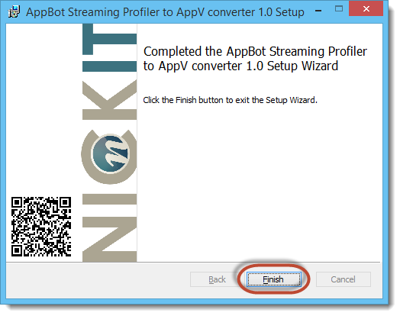

Click „Finish“

Desktop Icon and a Startmenu entray are created

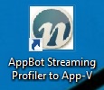

# User Guide

First start the Application. Use “Right Mousebutton” and “Run as Administrator” if you like to create a App-V 5 Package. This is not needed for the MSI output.

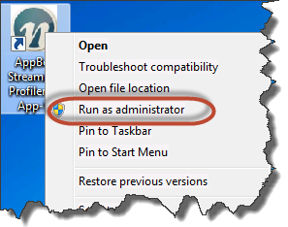

## Main Application Dialog

First, create a “New Project”. The default path is "MyDocuments\ ctxstr2msi\Projects\ " . Create a new folder for your project (Office 2003 or so).

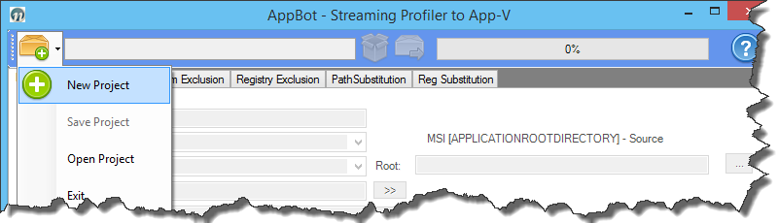

Now you can open a Streaming Profiler Package

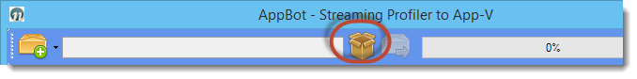

The Application try to detect all needed settings from the application registry. When no settings can found, a intelligent algoithmus try to set working values. All Filesystem exclusions and substitutions are imported from a xml file in the AppBot Program directory. You can edit this file if you like for new “Global Settings”

**AppBot now extract all application icons from the icon.bin file. This need some time for many bit Operation. Citrix use 4 bits for one pixel and a bitmask[2]** This is only needed in the first detection. All Icons are automatically saved with the project.

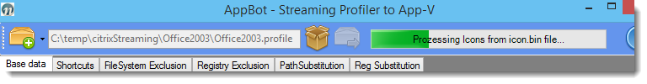

The Fields for the application a filled. Today, we have no test Application that not work with the detected setting.

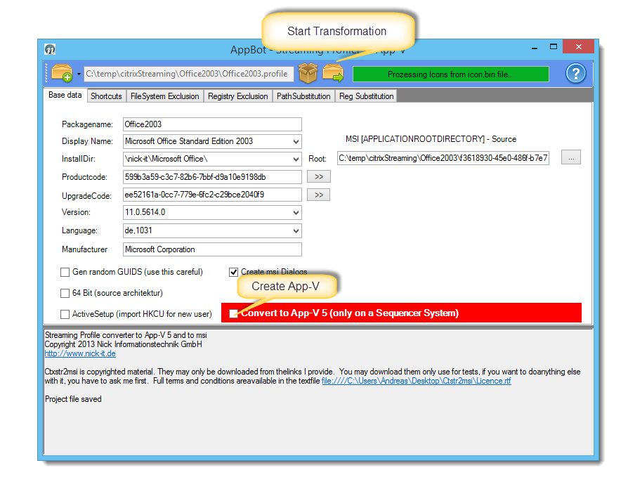

Now you can start the transformation, if you like!

## Description of the fields

* **Packagename**generate <PackageName>.Msi and a Folder <PackageName>-appv with the .appv package
* **Display Name**  
  Display in view of installed programs
* **Install Dir**  
  installation path to c: \%Programfiles%\<InstallDir>.   
  The path can be changed, if you don’t like “\Nick-IT\<YOURAPPLICATIONNAME>
* **Productcode**This is the MSI Productcode. You can find this Code in HKLM\Software\Microsoft\Widnows\CurrentVersion\Uninstall. The Original Productoce ist Replaced!
* **Upgradecode**This is the MSI Upgradecode. You can find this Code in HKLM\Software\Microsoft\Widnows\CurrentVersion\Uninstally\<PRODUCTCODE>. The Original Productoce ist Replaced! If you like to Upgrade your Package later, please use the same settings for the same product
* **Root:**   
  This field is very important. AppBot try to detect a version of the Streaming Profiler Package. And the root of the Application. This will be the “APPLICATIONROOTDIRECTORY” in the MSI. Please check this files, if you have a problem with your package! You can transform your Installation with msiexe.exe “YourMsi” APPLICATIONROOTDIRECTORY=c”:\Program Files\MyCompalyname\myApplication”
* **Version**  
  Please enter the Version the MSI x.x.x.x notation here , for example, 24.0.0.0 , if not correct detected
* **Language**Please select if not correct detected. Only English an German are supported today
* **Manufacturer**Please enter, if not correct detected
* **Gene random GUID** - created the system based random key. This may be necessary in Extensive applications.
* **Create msi dialogs  
  Generate a MSI with beautiful the “Nick-IT” Dialogset.** These Dialogs can be replaced with your own “C:\Program Files (x86)\AppBot-CtxStr2AppV\Dialogs”. App-V generation automatic disable the Dialog creation
* **64 Bit**  
  This switch must be set if this is the application is a “real” 64 bit application. Otherwise, the 64-bit application installs to c:\Program Files ( x86) and RegKeys to HKLM\Software\wow6432node
* **Active Setup**It will set the Active Setup key for new users. There is a service running when you first registered for the msi with the Product Code. New users automatically receive all the necessary files to% appdata %, for example . Furthermore, the registry key under HKCU. This will not uninstall the Terminal Server compatibility. This was a Feature for our App-V to Msi Converter. So you can very easy create Application Brandings. The Streaming Profiler don’t support the settings in the Userprofile. The best way here is to copy the user settings to %ALLUSERSPROFILE%[3]
* **Convert to App-V**This is only supportet, if you run the Application on a Client with Microsoft App-V 5 Sequencer installed. You get a Message, if not. Dialog Creation is now disabled. In The Process the generated MSI is installed and uninstalled. You don’t need the GUI Sequencer because the are no User settings in the Streaming profile. The Streaming Profiler don’t sequence the User Settings! The Process can take a long time (10 Minutes for Office). You can try to disable the Certificate check in the Internet Explorer to get this faster.  
    
  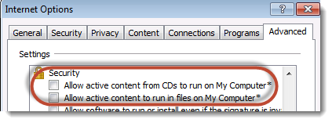
* **Press „Start" is the build process.**

## Shortcut Management

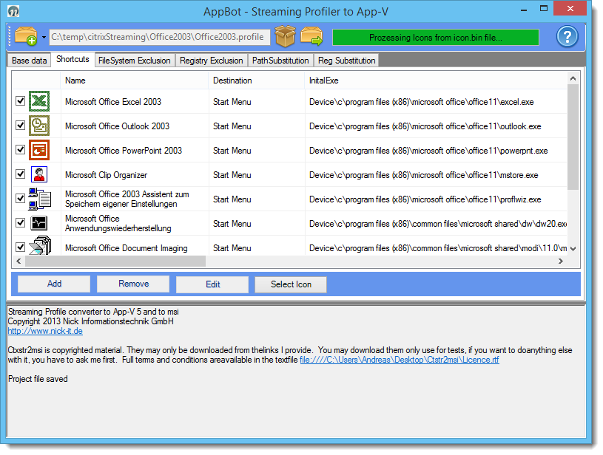

You can select the Shortcuts, you need in your App-V Package or in you MSI. The AppBot use only selected Icons. Editing the settings is not Supported (now). You can select a new Icon from the extracted icons but the App-V and MSI Installer only use the original Allication Icons. We will change this later. All Application paths automatically transformed from the AppBat to the new destiny Platform.

## FilesSystem Exclusion

Here exclusions from the Streaming Profiler file system are defined. So folders to be ignored during the conversion.

The software works with **regular expressions**, is there a backslash to put each a double „\\„. Possibly extend some entrees here after reviewing the logs.

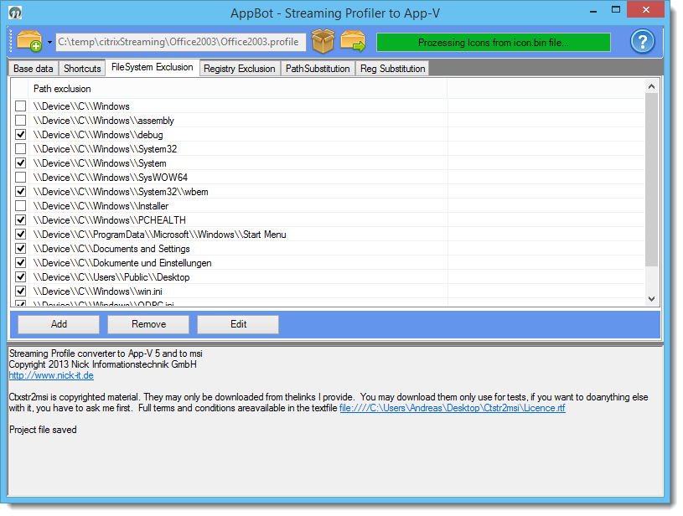

Only the checked entries are used for the transformation!

Here the full default List from the File Ctx2msi_Windows7_64Bit_Settings.xml

<CtxStr_EXCLUDE_DIR>

<Row field0="" field1="Path exclusion" />

<Row field0="20" field1="500" />

<Row field0="False" field1="\\Device\\C\\Windows" />

<Row field0="False" field1="\\Device\\C\\Windows\\assembly" />

<Row field0="True" field1="\\Device\\C\\Windows\\debug" />

<Row field0="False" field1="\\Device\\C\\Windows\\System32" />

<Row field0="True" field1="\\Device\\C\\Windows\\System" />

<Row field0="False" field1="\\Device\\C\\Windows\\SysWOW64" />

<Row field0="True" field1="\\Device\\C\\Windows\\System32\\wbem" />

<Row field0="False" field1="\\Device\\C\\Windows\\Installer" />

<Row field0="True" field1="\\Device\\C\\Windows\\PCHEALTH" />

<Row field0="True" field1="\\Device\\C\\ProgramData\\Microsoft\\Windows\\Start Menu" />

<Row field0="True" field1="\\Device\\C\\Documents and Settings" />

<Row field0="True" field1="\\Device\\C\\Dokumente und Einstellungen" />

<Row field0="True" field1="\\Device\\C\\Users\\Public\\Desktop" />

<Row field0="True" field1="\\Device\\C\\Windows\\win.ini" />

<Row field0="True" field1="\\Device\\C\\Windows\\ODBC.ini" />

<Row field0="True" field1="\\.CTX.Placeholder.txt" />

</CtxStr_EXCLUDE_DIR>

## Registry Exclusion

Here exclusions from the Streaming Profiler application Registry are defined. So Hives to be ignored during the conversion.

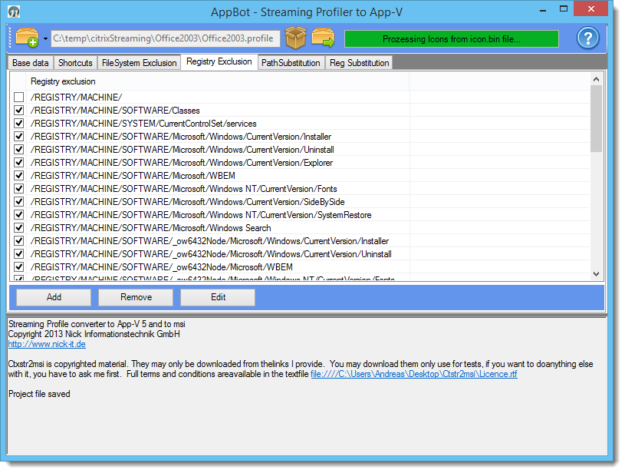

Only the checked entries are used for the transformation!

The settings are for Windows XP/2003, Windows 7 32 Bit and Windows 7 64 Bit

Here the full default List from the File Ctx2msi_Windows7_64Bit_Settings.xml

<CtxStr_EXCLUDE_REG_HIVES>

<Row field0="" field1="Registry exclusion" />

<Row field0="20" field1="500" />

<Row field0="False" field1="/REGISTRY/MACHINE/" />

<Row field0="True" field1="/REGISTRY/MACHINE/SOFTWARE/Classes" />

<Row field0="True" field1="/REGISTRY/MACHINE/SYSTEM/CurrentControlSet/services" />

<Row field0="True" field1="/REGISTRY/MACHINE/SOFTWARE/Microsoft/Windows/CurrentVersion/Installer" />

<Row field0="True" field1="/REGISTRY/MACHINE/SOFTWARE/Microsoft/Windows/CurrentVersion/Uninstall" />

<Row field0="True" field1="/REGISTRY/MACHINE/SOFTWARE/Microsoft/Windows/CurrentVersion/Explorer"/>

<Row field0="True" field1="/REGISTRY/MACHINE/SOFTWARE/Microsoft/WBEM" />

<Row field0="True" field1="/REGISTRY/MACHINE/SOFTWARE/Microsoft/Windows NT/CurrentVersion/Fonts" />

<Row field0="True" field1="/REGISTRY/MACHINE/SOFTWARE/Microsoft/Windows/CurrentVersion/SideBySide" />

<Row field0="True" field1="/REGISTRY/MACHINE/SOFTWARE/Microsoft/Windows NT/CurrentVersion/SystemRestore" />

<Row field0="True" field1="/REGISTRY/MACHINE/SOFTWARE/Microsoft/Windows Search" />

<Row field0="True" field1="/REGISTRY/MACHINE/SOFTWARE/_ow6432Node/Microsoft/Windows/CurrentVersion/Installer" />

<Row field0="True" field1="/REGISTRY/MACHINE/SOFTWARE/_ow6432Node/Microsoft/Windows/CurrentVersion/Uninstall" />

<Row field0="True" field1="/REGISTRY/MACHINE/SOFTWARE/_ow6432Node/Microsoft/WBEM" />

<Row field0="True" field1="/REGISTRY/MACHINE/SOFTWARE/_ow6432Node/Microsoft/Windows NT/CurrentVersion/Fonts" />

<Row field0="True" field1="/REGISTRY/MACHINE/SOFTWARE/_ow6432Node/Microsoft/Windows/CurrentVersion/SideBySide" />

<Row field0="True" field1="/REGISTRY/MACHINE/SOFTWARE/_ow6432Node/Microsoft/Windows NT/CurrentVersion/SystemRestore" />

<Row field0="True" field1="/REGISTRY/MACHINE/SOFTWARE/_ow6432Node/Microsoft/Windows Search" />

<Row field0="False" field1="/REGISTRY/USER/.DEFAULT" />

<Row field0="False" field1="/REGISTRY/USER/CurrentUser" />

<Row field0="False" field1="/REGISTRY/USER/CurrentUser_CLASSES" />

<Row field0="True" field1="/REGISTRY/USER/CurrentUser_CLASSES/_wow6432Node" />

<Row field0="True" field1="/REGISTRY/USER/CurrentUser/Software/Classes/Local Settings/MuiCache" />

<Row field0="True" field1="/REGISTRY/USER/CurrentUser/Software/Microsoft/Windows/CurrentVersion/Explorer"/>

<Row field0="True" field1="/REGISTRY/USER/CurrentUser/Software/Microsoft/Windows/CurrentVersion/Explorer/RecentDocs" />

<Row field0="True" field1="/REGISTRY/USER/CurrentUser/Software/Microsoft/Windows/CurrentVersion/Explorer/StartPage" />

<Row field0="True" field1="/REGISTRY/USER/CurrentUser/Software/Microsoft/Windows/CurrentVersion/Explorer/StartPage2" />

<Row field0="True" field1="/REGISTRY/USER/CurrentUser/Software/Microsoft/Windows/CurrentVersion/Internet Settings" />

<Row field0="True" field1="/REGISTRY/USER/CurrentUser/Software/Microsoft/Windows/CurrentVersion/Shell Extensions/Cached" />

<Row field0="True" field1="/REGISTRY/USER/CurrentUser/Software/_ow6432Node/Classes/Local Settings/MuiCache" />

<Row field0="True" field1="/REGISTRY/USER/CurrentUser/Software/_ow6432Node/Microsoft/Windows/CurrentVersion/Explorer"/>

<Row field0="True" field1="/REGISTRY/USER/CurrentUser/Software/_ow6432Node/Microsoft/Windows/CurrentVersion/Explorer/RecentDocs" />

<Row field0="True" field1="/REGISTRY/USER/CurrentUser/Software/_ow6432Node/Microsoft/Windows/CurrentVersion/Explorer/StartPage" />

<Row field0="True" field1="/REGISTRY/USER/CurrentUser/Software/_ow6432Node/Microsoft/Windows/CurrentVersion/Explorer/StartPage2" />

<Row field0="True" field1="/REGISTRY/USER/CurrentUser/Software/_ow6432Node/Microsoft/Windows/CurrentVersion/Internet Settings" />

<Row field0="True" field1="/REGISTRY/USER/CurrentUser/Software/_ow6432Node/Microsoft/Windows/CurrentVersion/Shell Extensions/Cached" />

<Row field0="True" field1="CitrixAIEKeyVirtualStatus" />

<Row field0="True" field1="CitrixAIEDeletedValues" />

</CtxStr_EXCLUDE_REG_HIVES>

## Path Substitution

These settings are used to converted the Streaming Profiler package directorys to MSI variables. A special feature is that only the root paths wander into the MSI, which were marked. All other Directorys will be ignored! Some projects will require significant extensions.

An overview of MSI Built-in Variables can be found in the WiX documentation:

<http://wixtoolset.org/documentation/manual/v3/bundle/bundle_built_in_variables.html>

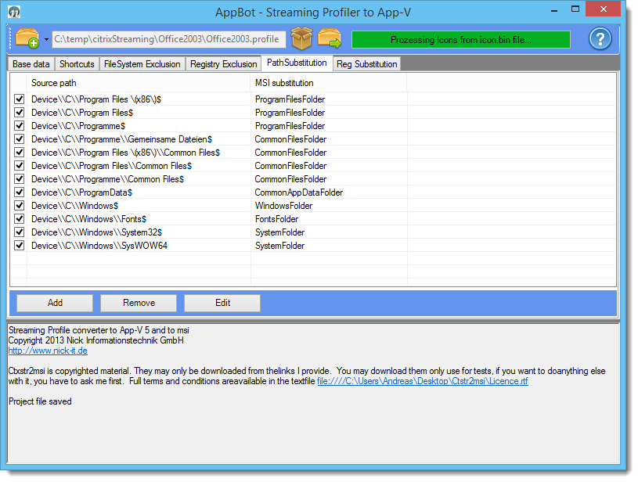

Only the checked entries are used for the Package!

The settings are for Windows XP (german)/2003, Windows 7 32 Bit and Windows 7 64 Bit (multilingual)

Here the full default List from the File Ctx2msi_Windows7_64Bit_Settings.xml

<CtxStr_PATH_SUBST>

<Row field0="" field1="Source path" field2="MSI substitution" />

<Row field0="20" field1="200" field2="200" />

<Row field0="True" field1="Device\\C\\Program Files \(x86\)$" field2="ProgramFilesFolder" />

<Row field0="True" field1="Device\\C\\Program Files$" field2="ProgramFilesFolder" />

<Row field0="True" field1="Device\\C\\Programme$" field2="ProgramFilesFolder" />

<Row field0="True" field1="Device\\C\\Programme\\Gemeinsame Dateien$" field2="CommonFilesFolder" />

<Row field0="True" field1="Device\\C\\Program Files \(x86\)\\Common Files$" field2="CommonFilesFolder" />

<Row field0="True" field1="Device\\C\\Program Files\\Common Files$" field2="CommonFilesFolder" />

<Row field0="True" field1="Device\\C\\Programme\\Common Files$" field2="CommonFilesFolder" />

<Row field0="True" field1="Device\\C\\ProgramData$" field2="CommonAppDataFolder" />

<Row field0="True" field1="Device\\C\\Windows$" field2="WindowsFolder" />

<Row field0="True" field1="Device\\C\\Windows\\Fonts$" field2="FontsFolder" />

<Row field0="True" field1="Device\\C\\Windows\\System32$" field2="SystemFolder" />

<Row field0="True" field1="Device\\C\\Windows\\SysWOW64" field2="SystemFolder" />

</CtxStr_PATH_SUBST>

## Reg Substitution

Converts the Streaming Profiler registry Keys to msi variables. Missing variables are reported in the log.

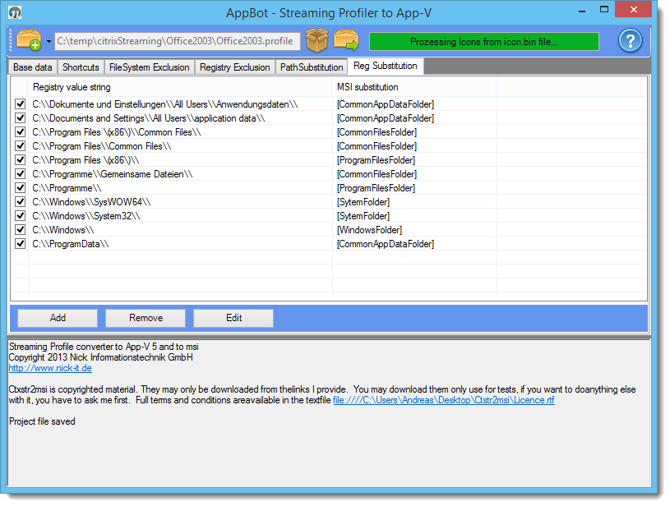

**ATTANTION:** Use the longest path in the top. The shorter paths later. The registry is converted from top to down. We need first to substitute c:\\Program Files\\Common Files\\. If this not match c:\\Program Files\\ ! Please besser use a texteditor an not the Frondend to edit these settings!

# Troubleshooting

## Missing substitution

#### IMPORTANT INFO [ .. ] value not found in the substitution table . Please make an entry: [{desktop ] \ ....

#### Substitution is still missing in the registry. This needs to be complemented in the projectNote: We will ask for information which paths should be included here as standard!

#### Important links in this context:

WiX Burn Built-in Variables:

<http://wixtoolset.org/documentation/manual/v3/bundle/bundle_built_in_variables.html>

Infos from Microsoft:

<http://msdn.microsoft.com/en-us/library/windows/desktop/dd378457(v=vs.85).aspx>

<http://msdn.microsoft.com/en-us/library/windows/desktop/bb762494(v=vs.85).aspx>

## Log analysis

In the project directory are the following files under "Logs" created:

* CtxStr2XML.log .log (log of the generator. Corresponds to the output in the dialog box )
* <AppName>. Candle.log (log of the WiX Candle generator. , If no MSI was generated , please check here first .
* <AppName>. Msi.log (log of the WiX Light generator. Error messages when creating the MSI)
* <AppName>. Xml ( WiX template file that was generated with the tool appv2msi
* The logs contain partially many warnings and errors, some of it is eliminated with new versions. You can also use this as template for a new Windows Installer XML Application

## Creation of updates

Currently, a largely untested function. A proper update is dependent on clean guids . This may not be generated randomly. So leave the switch "gene random Guid” out! The guids are then generated based on the path name. The directory must not change! It must be added a new upgrade code. The generated product code and upgrade code must be identical to the previous version. Furthermore, a new version number must be entered. The version number has the msi format must be followed. So is 1.0.0.0 to 1.0.1.0. It will be of the MSI considers only the first three values ​​. So at least at the third position change! The GUIDs are generated by the project path. The date must be exactly identical to the previous version. So the same project directory with the same path. The old directory you should back up! Please check the product code generated in any case! If identical, the new version can be generated.

**ATTENTION:** Be careful with this feature. Some functions are not implemented. Better you install a new Release of your software.

# Links

**Windows Installer XML** <http://wixtoolset.org>

**reglookup** <http://projects.sentinelchicken.org/reglookup/>

**Citrix Streaming Profiler (6.0.2)** <http://support.citrix.com/article/CTX127850>

1. We can substitute this tool with a registry mount. But we think, it is better not to access the system registry.
2. The Icons are installed with the package. So you can use the icons for publishing with XenApp an XenDesktop
3. We plan to allow a new folder in the Profile Directory for real personal settings also with the Streaming profiler